**Project Design Phase-II**

**Data Flow Diagram & User Stories**

|  |  |
| --- | --- |
| Date | 27 June 2025 |
| Team ID | LTVIP2025TMID35292 |
| Project Name | **TrafficTelligence**: advanced traffic volume estimation with machine learning |
| Maximum Marks | 4 Marks |

**Data Flow Diagrams:**

A Data Flow Diagram (DFD) is a traditional visual representation of the information flows within a system. A neat and clear DFD can depict the right amount of the system requirement graphically. It shows how data enters and leaves the system, what changes the information, and where data is stored.

Example: DFD Level 0 (Industry Standard)

**Example: (Simplified)**

**UML Class Diagram for TrafficTelligence**

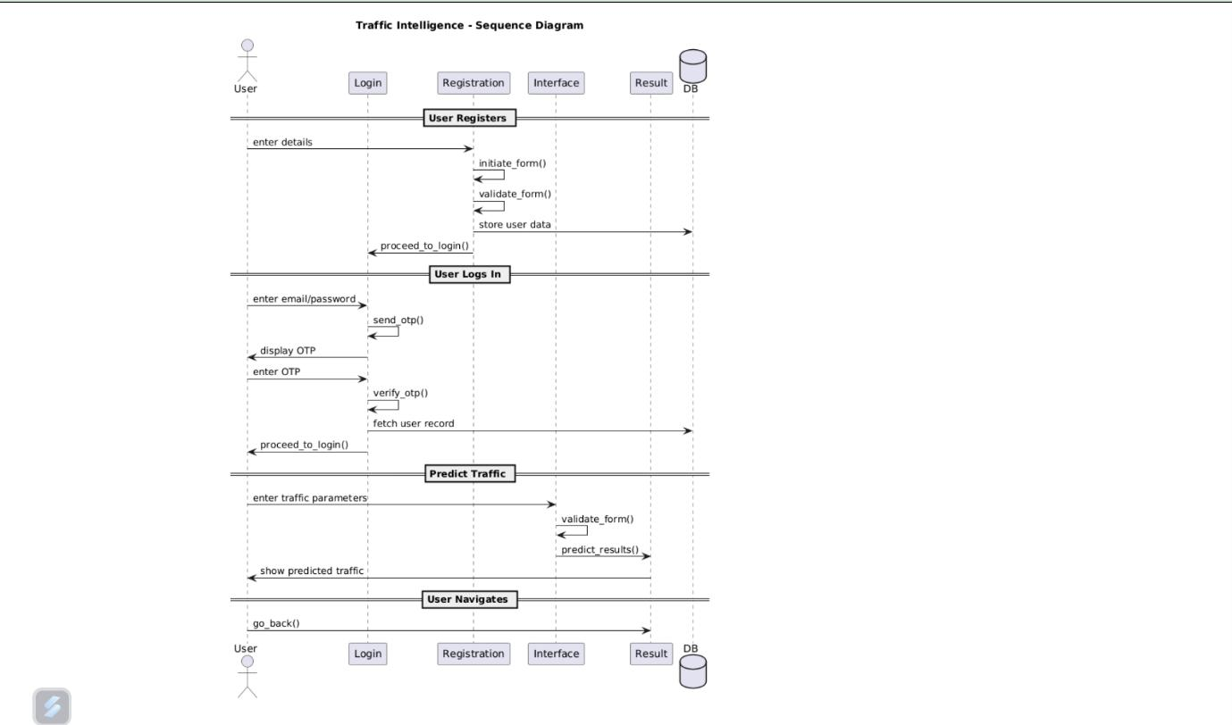

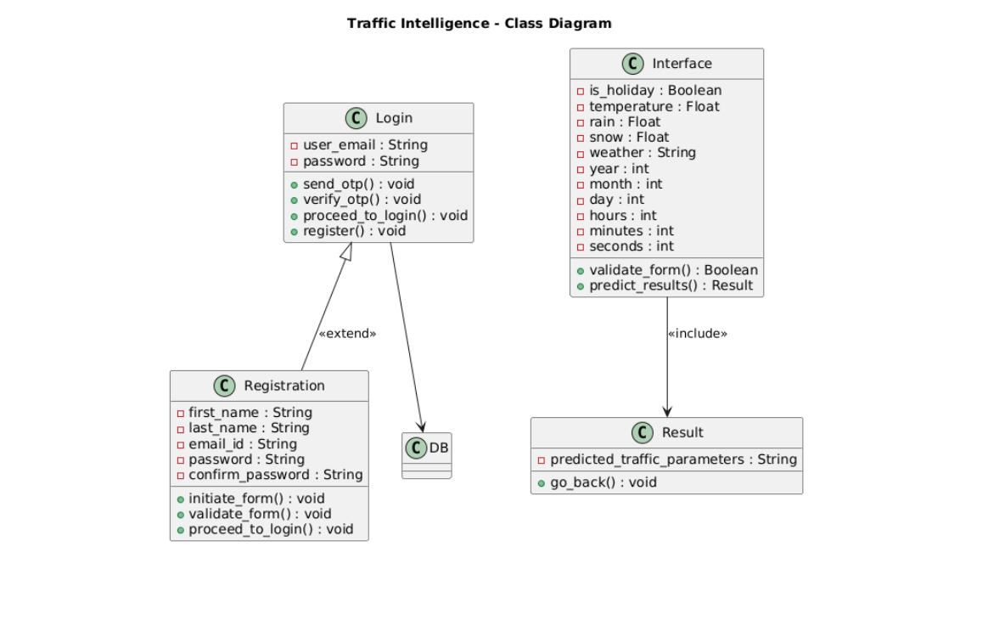

**User Stories**

Use the below template to list all the user stories for the product.

| **Functional Requirement (Epic)** | **User Story Number** | **User Story / Task** | **Acceptance criteria** | **Priority** | **Release** |
| --- | --- | --- | --- | --- | --- |
| Registration | USN-1 | As a user, I can register for the application by entering my email, password, and confirming my password. | User account is created and data stored in MongoDB | High | Sprint-1 |
| Registration | USN-2 | As a user, I will receive confirmation email once I have registered for the application | OTP is sent via email successfully | High | Sprint-1 |
| Login | USN-3 | As a user, I can verify my OTP to complete login. | OTP is verified and user is redirected to dashboard | Low | Sprint-2 |
| Login | USN-4 | As a user, I can login using my email and password | Credentials are validated and OTP is triggered | High | Sprint-1 |
| Prediction Interface | USN-5 | As a user, I can input traffic parameters via a web form | Form accepts all inputs and validate fields | High | Sprint-2 |
| Prediction Interface | USN-6 | As a user, I receive the traffic volume prediction after submittting results | System returns predicted volume and shows results on UI | High | Sprint-2 |
| Adminsitrator | User Management | As an admin, I can access user registrations and system logs | Admin panel will lists the user data and logs | Medium | Future |